Mini-Project Report

On

**Hospital** Database Management System

By

Name:

Section:

Roll number:

Course: INT-306

Submitted To: Dr.Balraj Singh

1. **Storyline:**

Organisations such as hospitals have to deal with a lot of patients regularly and hence a lot of data. Hence it is very important for a hospital to have a DBMS so the doctors can

have a record of patients and by the end the doctor will get

only the final report of various tests that were performed so that it will make things easy for doctors

For this project I have chosen to build the database used will be Oracle

I am making my first table which contains the details of doctors and to which branch they belong to.

The second table contains the essential details of patients which are required to contact them, their initial symptoms

The third table contains the after details of patients after there

Medical test

The semi-last table is related to report as the report show what type of disease that the person is suffering its directs to id of doctor to which he/she belong to

The final table deals with medicines that the doctors give to the patient and the hospital also keeps the record of medicines

Given by doctors.

1. **ER Diagram:**

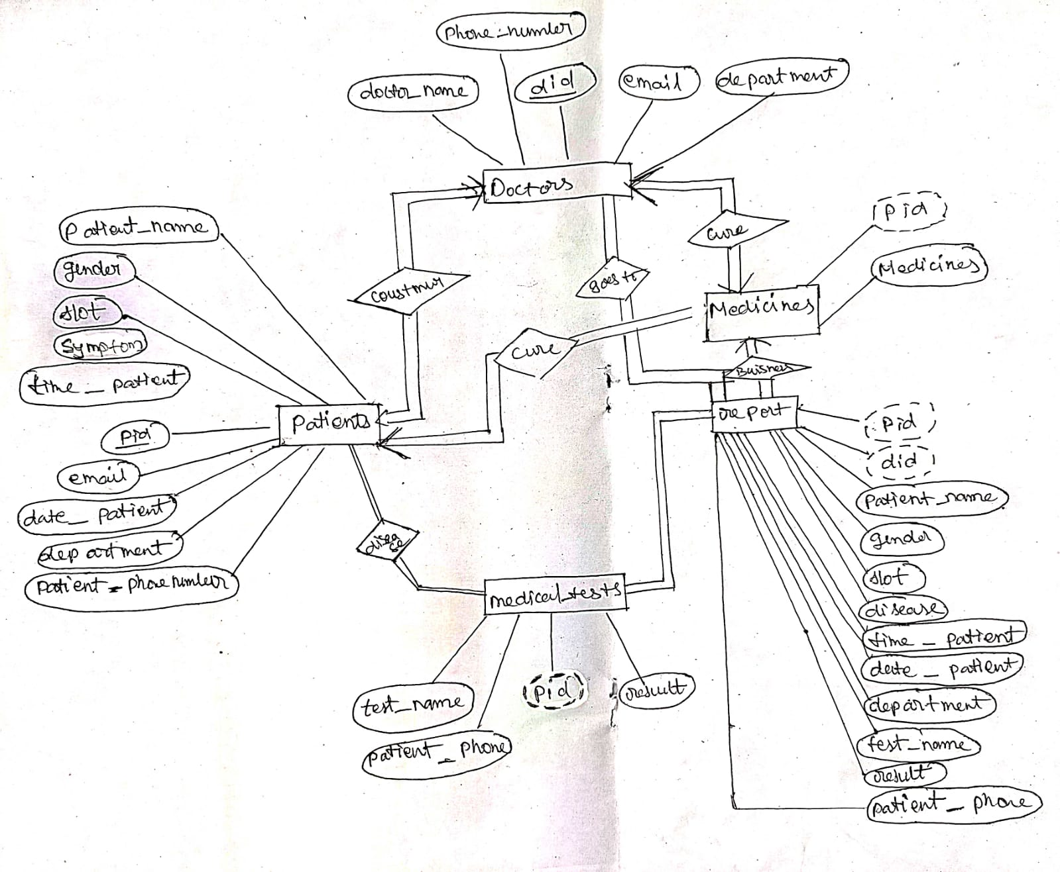

1. **The entities and their respective attributes required are as follows:**

* Doctors

Attributes:

* did (number)
* email (varchar(50),)
* doctor_name( varchar(50))
* department (varchar(50))
* phone_number(number)
* Patients

Attributes:

* pid (number )
* email (varchar(50) )
* patient_(name varchar(50) )
* gender (varchar(50) )
* slot (varchar(50) )
* symptom (varchar(50) )
* time_patient (varchar(20))
* date_patient (varchar(20))
* department (varchar(50))
* patient_phone (number)
* medical_tests

Attributes:

* pid (number)
* test_name ( varchar(20))
* Result( varchar(20))
* patient_(phone number)
* Report

Attributes:

* pid (number)
* did (number)
* patient_name (varchar(50))
* gender (varchar(50))
* Slot( varchar(50) )
* Disease( varchar(50) )
* time_patient( varchar(20))
* date_patient (varchar(20)
* department (varchar(50))
* test_name( varchar(20))
* result (varchar(20))
* patient_phone (number)
* Mediciens

Attributes:

* pid (number)
* medicien (varchar(100))

**VI. SQL Queries**

**CREATE TABLE**

* **Doctors**

create table doctors

( did number primary key,

email varchar(50),

doctor_name varchar(50),

department varchar(50) not null,

phone_number number not null

);

///insert values using plsql ////

declare

begin

insert into doctors values(1, 'aneesh@gmail.com', 'aneesh', 'Cardiologists',5638794259);

insert into doctors values(2, 'bmrutha@gmail.com', 'bmrutha bhatta', 'Dermatologists',9986512347);

insert into doctors values(3, 'adithya@gmail.com', 'adithya', 'Anesthesiologists',6302157865);

insert into doctors values(4, 'teja@gmail', 'teja', 'Endocrinologists',9502514339);

insert into doctors values(5, 'tajesh@gmail.com', 'tajesh', 'Morchery',8886576758);

end;

select * from doctors

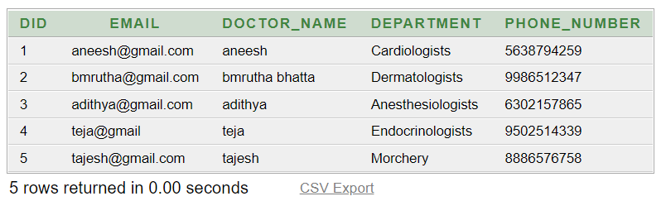

* **Patients**

create table patients

(pid number primary key,

email varchar(50) not null,

patient_name varchar(50) not null,

gender varchar(50) not null,

slot varchar(50) not null,

symptom varchar(50) not null,

time_patient varchar(20),

date_patient varchar(20),

department varchar(50),

patient_phone number

)

declare

begin

insert into patients values(5, 'patient@gmail.com', 'patien', 'Male', 'morning', 'fevr', '18:06:00', 'sysdate', 'Cardiologists', '9874563210');

insert into patients values(7, 'patient2@gmail.com', 'patien1', 'Male', 'evening', 'cold', '22:18:00', 'sysdate', 'Dermatologists', '9874563210');

insert into patients values(8, 'patient3@gmail.com', 'patien2', 'Male', 'evening', 'diarrhoea', '22:18:00', '2020-11-05', 'Dermatologists', '9874563210');

insert into patients values(9, 'patient4@gmail.com', 'patien3', 'Male', 'morning', 'diarrhoea', '17:27:00', '2020-11-26', 'Anesthesiologists', '9874563210');

insert into patients values(10, 'patient5@gmail.com', 'patien4', 'Male', 'evening', 'fever', '16:25:00', '2020-12-09', 'Cardiologists', '9874589654');

insert into patients values(15, 'patient6@gmail.com', 'patien5', 'Female', 'morning', 'diarrhoea', '20:42:00', '2021-01-23', 'Anesthesiologists', '9874563210');

insert into patients values(16, 'patient7@gmail.com', 'patien6', 'Female', 'evening', 'fever', '15:46:00', '2022-01-31', 'Endocrinologists', '9874587496');

insert into patients values(17, 'patient8@gmail.com', 'patien7', 'Female', 'evening', 'fever', '15:48:00', '2022-01-23', 'Endocrinologists', '9874563210');

insert into patients values(2, 'patuent1@gmail.com', 'rehman ', 'Male', 'evening1', 'cold1','18:25:45' , sysdate, 'ortho11predict', '9874561110');

end;

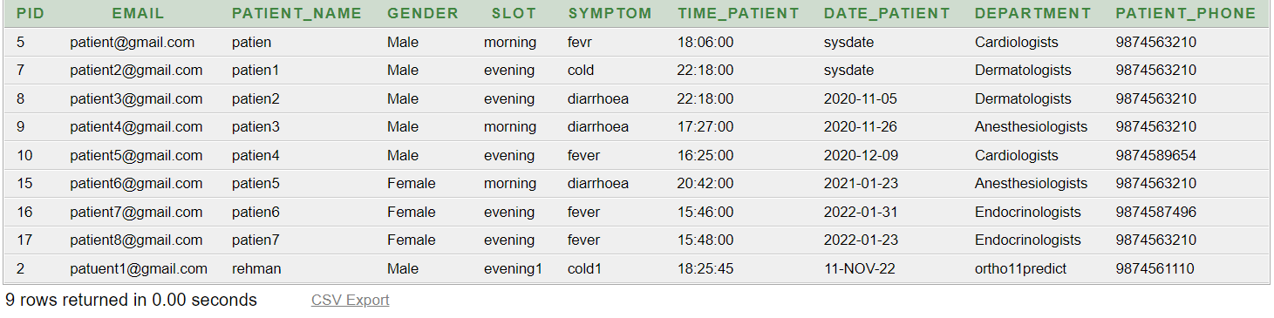

* **medical_tests**

create table medical_tests

(

pid number references patients(pid),

test_name varchar(50),

result varchar(50),

patient_phone number

)

declare

begin

insert into medical_tests values('5','Adreno Corticotropic Hormone','positive','9874563210');

insert into medical_tests values('7','Adenosine Deaminase Test ','advanced','9874563210');

insert into medical_tests values('8','AFB (Acid Fast Bacilli) Culture Test ','begging','9874563210');

insert into medical_tests values('9','Factor V Leiden Test ','negetive','9874563210');

insert into medical_tests values('10','Stress Echo Test','low','9874563210');

insert into medical_tests values('15','Renal Profile ','good','9874563210');

insert into medical_tests values('16','Factor V Leiden Test','advanced','9874563210');

insert into medical_tests values('17','Homocysteine Test ','advanced','9874563210');

end;

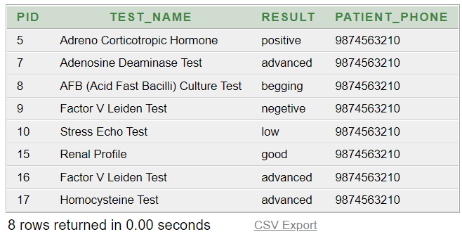

* report

create table report

(

pid number,

did number references doctors(did),

patient_name varchar(50) not null,

gender varchar(50) not null,

slot varchar(50) not null,

disease varchar(50) not null,

time_patient varchar(20),

date_patient varchar(20),

department varchar(50) ,

test_name varchar(50) ,

result varchar(50) ,

patient_phone number

)

declare

begin

insert into report values ('5','1','patien', 'Male', 'morning', 'fevr', '18:06:00', sysdate, 'Cardiologists','Adreno Corticotropic Hormone','positive', '9874563210');

insert into report values ('7','2','patien1', 'Male', 'evening', 'diarrhoea', '22:18:00', '2020-11-05', 'Dermatologists','Adenosine Deaminase Test ','advanced', '9874563210');

insert into report values ('8','3','patien2', 'Male', 'evening', 'cold', '22:18:00', sysdate, 'Dermatologists','AFB (Acid Fast Bacilli) Culture Test ','begging','9874563210');

insert into report values ('9','4','patien3', 'Male', 'morning', 'diarrhoea', '17:27:00', '2020-11-26', 'Anesthesiologists','Factor V Leiden Test ','negetive','9874563210');

insert into report values ('10','5','patien4', 'Male', 'evening', 'fever', '16:25:00', '2020-12-09', 'Cardiologists','Stress Echo Test','low','9874563210');

insert into report values ('15','3','patien5', 'Female', 'morning', 'diarrhoea', '20:42:00', '2021-01-23', 'Anesthesiologists','Renal Profile ','good','9874563210');

end;

select * from report

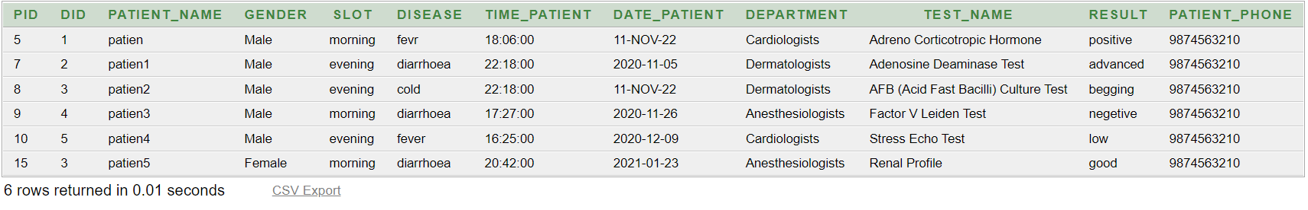

* medicine

create table mediciens

(

pid number references patients(pid),

medicien varchar(100)

)

declare

begin

insert into mediciens values ('5','Acebutolol ,Atenolol,Betaxolol,Bisoprolol,Bisoprolol') ;

insert into mediciens values ('7','betamethasone,triamcinolone,clobetasol');

insert into mediciens values ('8','betamethasone,triamcinolone,clobetasol');

insert into mediciens values ('9','propofol,ketamine,thiopental,methohexital');

insert into mediciens values ('10','Acebutolol ,Atenolol,Betaxolol,Bisoprolol,Bisoprolol');

insert into mediciens values ('15','propofol,ketamine,thiopental,methohexital');

end;

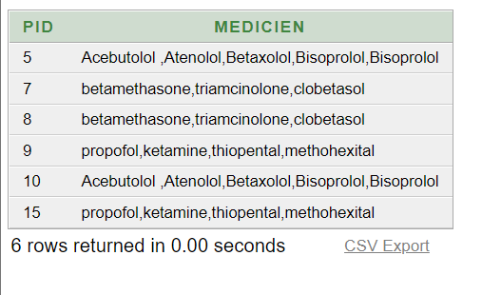

SQL QUERIES

Q1. A patient wants to know his/her medicines prescribed by doctor

Select MEDICIEN from mediciens where pid=5;

o/p:

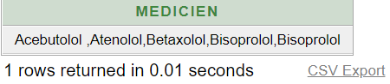

Q2. One of the patient’s symptoms were wrongly entered

update patients set symptom='skin infection' where pid=7;

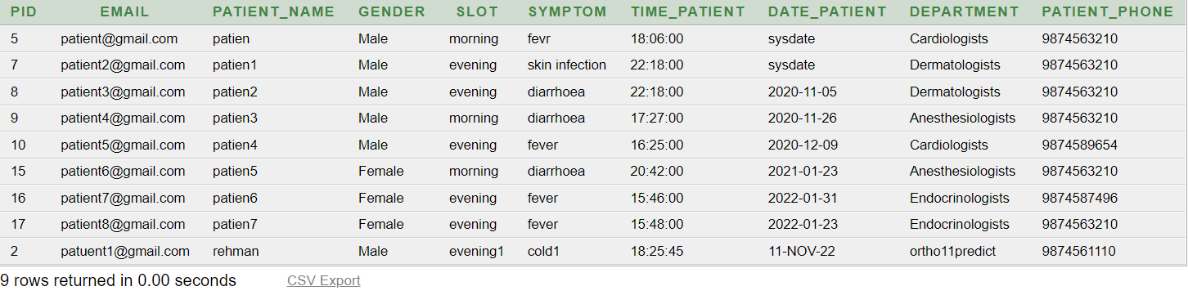

Q3. Find the did of all employees whose name includes the substring tej.

SELECT DID, doctor_name FROM doctors WHERE doctor_name LIKE '%tej%';

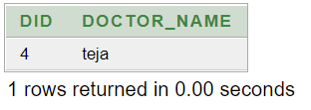

Q4. Find the patients of doctors according to their did?

select patient_name from report where did=2;

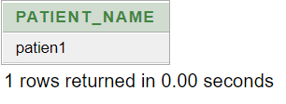

Q5. Find the pid of those patients who are prescribed to a Dermatologists

select pid from patients where department='Dermatologists';

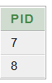

Q6. One attribute ‘disease‘ in table ‘report’ was wrongly entered change the name of the attribute to symptom

alter table report rename column disease to symptom;

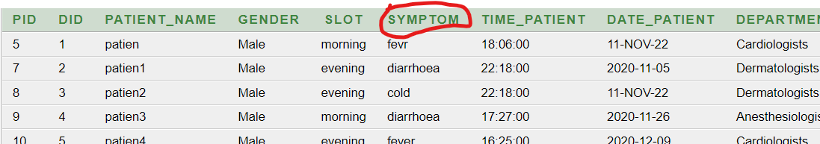

Q7. A patient with pid 2 has performed some medical test now you have to enter the results in run time using pl/sql and show them

declare

id number:=:enter_pid;

name_test varchar(50):=:enter_test;

results varchar(20):=:enter_results;

phone number:=:enter_phonemunber;

begin

insert into medical_tests values(id,name_test,results,phone);

end;

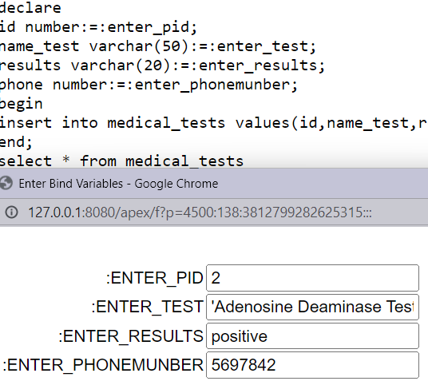

select * from medical_tests where pid=2;

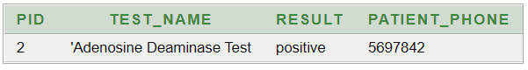

Q8. A new doctor has taken his joined in your hospital enter his details in run time using pl/sql .

declare

id number:=:enter_did;

email_doctors varchar(50):=:enter_email;

name varchar(20):=:enter_name;

department varchar(20):=:enter_department;

phone number:=:enter_phonemunber;

begin

insert into doctors values(id,email_doctors,name,department,phone);

end;

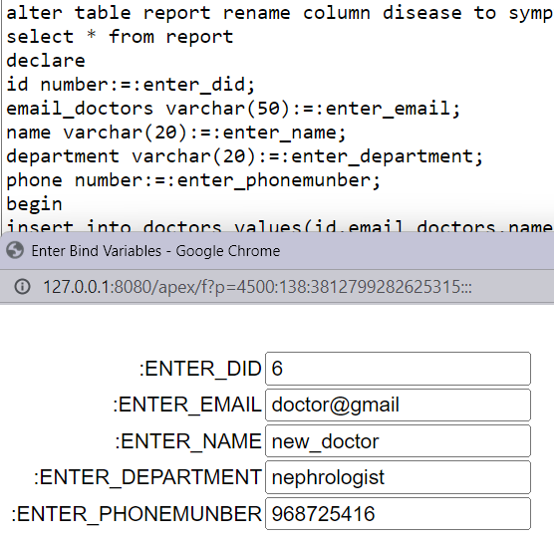

select * from doctors where pid=6; 